**Intro**

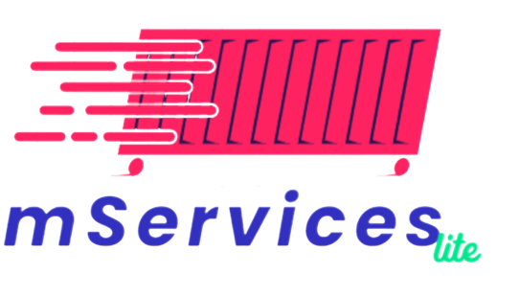

Through smart phones (Android & iOS), our customers can track their Shipments (BOLs & Containers), make inspection inquiry, generate pro-forma storage invoices, and check vessels schedule & vessels on berth.

**Set-up Considerations**

**For Android:**

mServices Lite is compatible for Android 4.4 and above devices

**For iPhone:**

mServices Lite is compatible for iOS 11 and above devices

**What’s New?**

1- Shipment Tracking Module:

In this module our customers can track their shipment and get the latest updates via email or SMS.

2- Container Search Module:

In this module our customers can know the location (Yard – Vessel – Out) and the actual Position inside the terminal for specific container.

3- Provide more Privacy for our customers

Users must enter the ACID number related to their bill of lading or container which they want to get information about to for the sake of our customers privacy.

4- Payment hold information is added to BL Tracking module

Our customers now can know that payment hold on their bill of lading is completely released or not.

5- Payment of storage invoices

Our customers now can not only generate estimated storage invoices but also can pay them inside the application.

6- Modern user interface

mServices Lite v.2.0.0 has been developed using the latest technology for mobile applications development providing modern user interface to enhance user experience inside the application.

**Landing Page**

To start navigation inside the application user has to press on start button

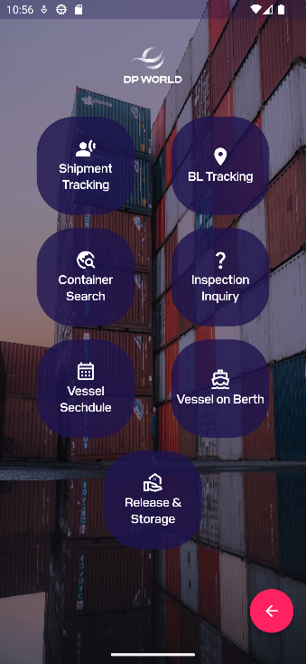

**Home Page**

User can navigate through different services such as:

1. Shipment Tracking
2. BL Tracking
3. Container Search
4. Inspection Inquiry
5. Vessel Schedule
6. Vessel on Berth
7. Release and storage invoices

**Shipment Tracking**

Users can track their shipment either bill of lading or container and get the latest updates via email or SMS.

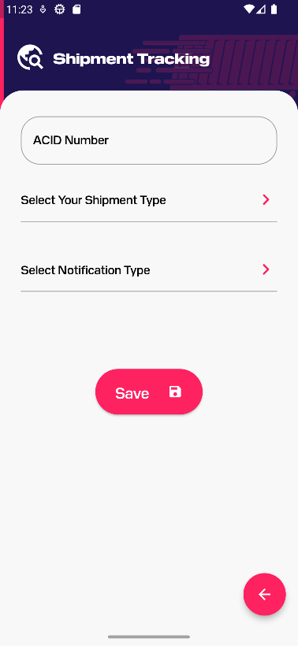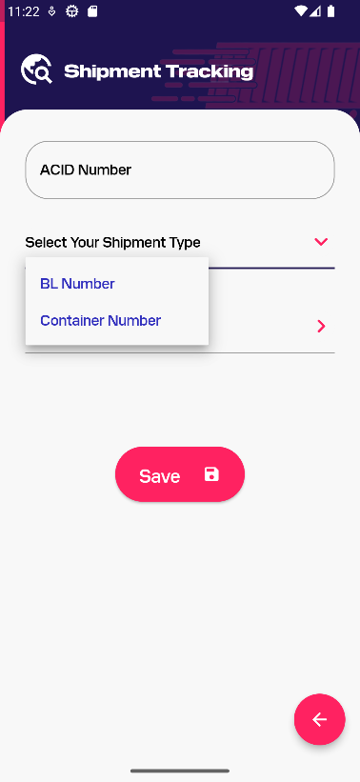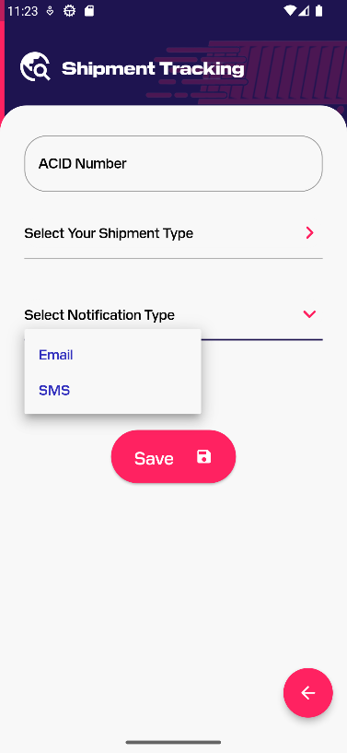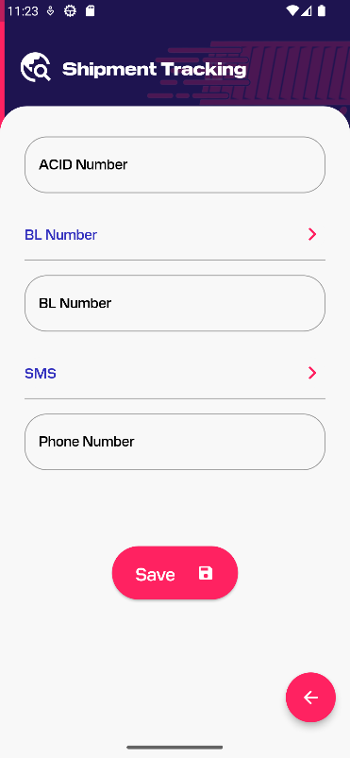

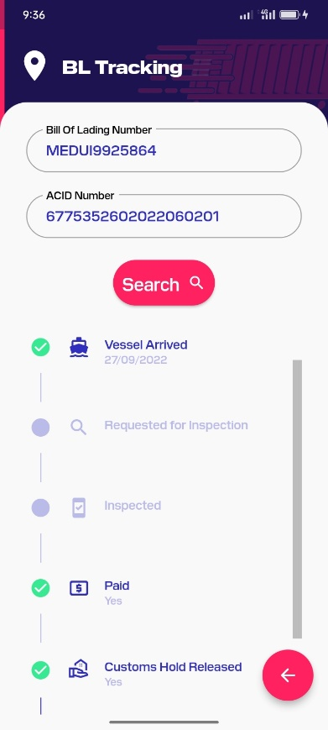

**BL Tracking**

Users can track a certain Bill of lading by knowing the following information:

1. Arrival date
2. Requested for inspection date and inspection date if it’s inspected
3. Payment hold released or not.
4. Customs hold released or not.
5. Gate out date.

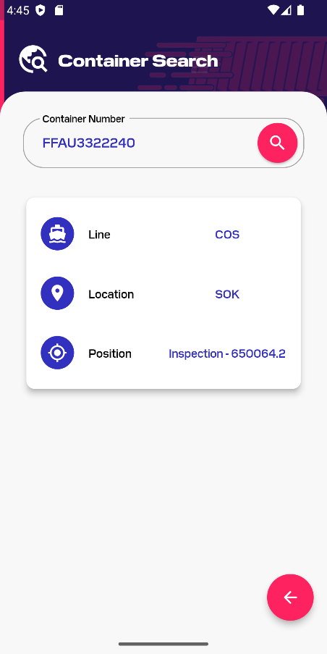**Container Search**

Users can search by container number and get the following information:

1. Shipping Line
2. Location (SOK for (SOKHNA) – Vessel – Out)
3. Position (position inside the terminal – Vessel – Out)

**Inspection Inquiry**

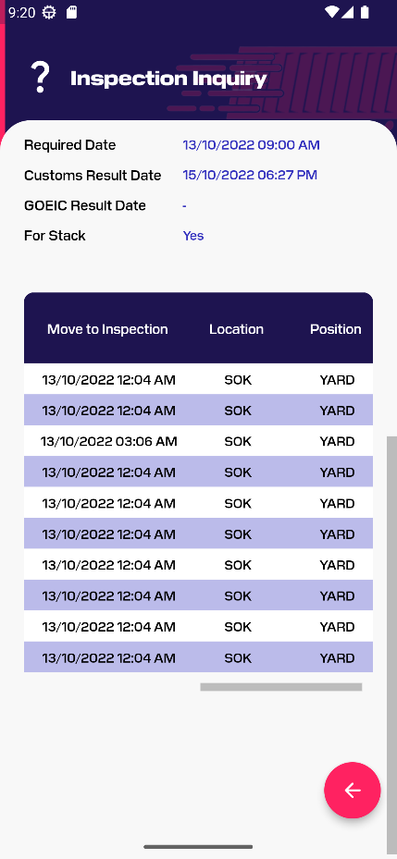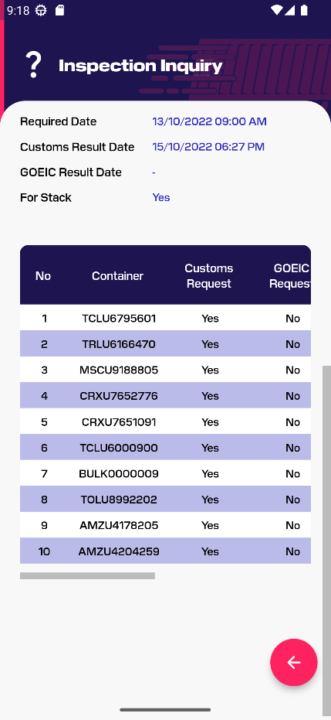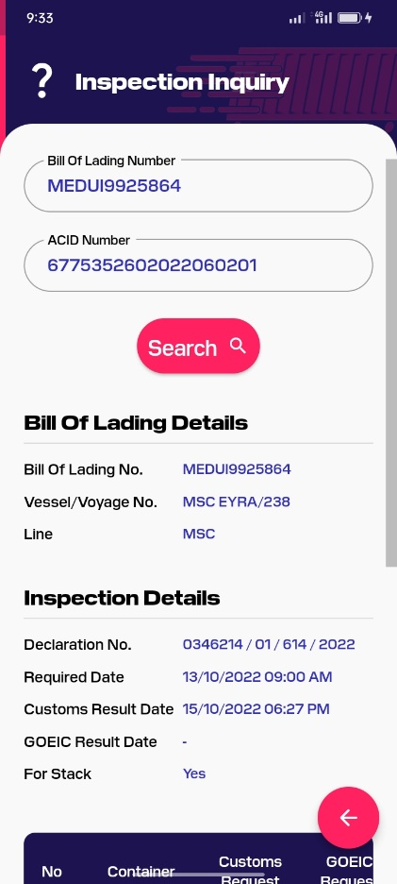Users can get details about Bill of lading such as vessel/voyage no, line and inspection details as shown

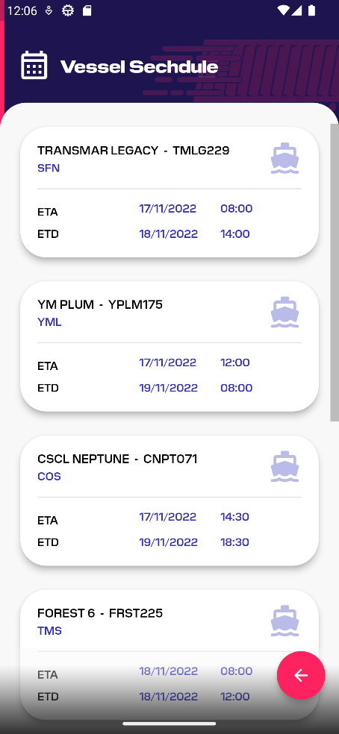**Vessel Schedule**

Users can get vessels schedule for all vessel within a week knowing the following information for each vessel:

1. Vessel Name (ex. TRANSMAR LEGACY)
2. Vessel Reference Code (ex. TMLG229)
3. Shipping Line (ex. SFN)
4. ETA (Estimated Time of Arrival)
5. ETD (Estimated Time of Departure)

**Vessel on Berth**

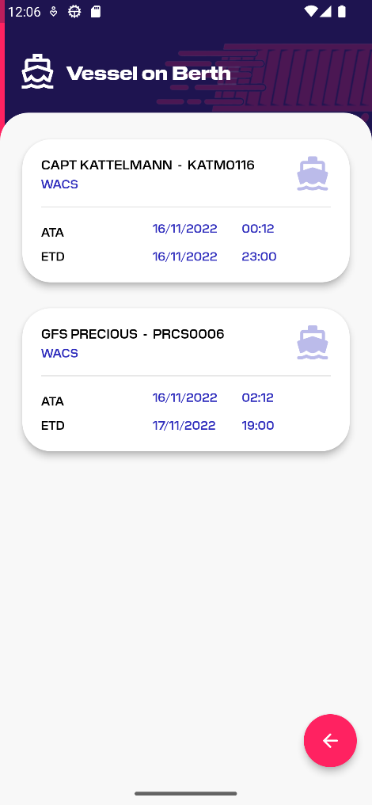

Users can get vessels on berth knowing the following information for each vessel:

1. Vessel Name (ex. TRANSMAR LEGACY)
2. Vessel Reference Code (ex. TMLG229)
3. Shipping Line (ex. SFN)
4. ATA (Actual Time of Arrival)
5. ETD (Estimated Time of Departure)

**Release & Storage**

Users can calculate estimated release & storage invoices and pay them.

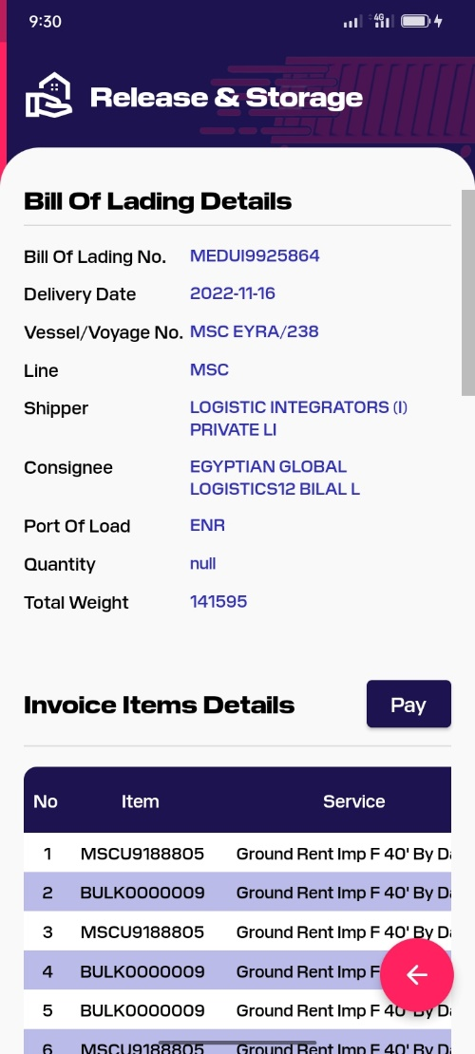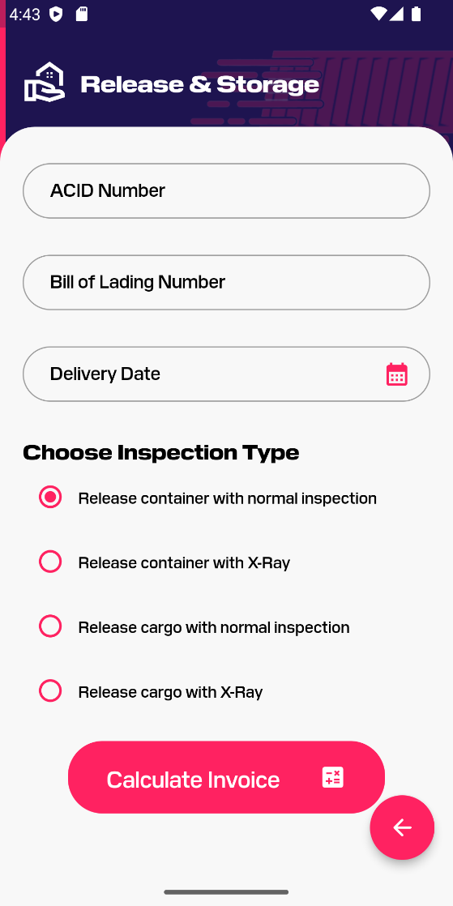

**Input Validations**

1. **ACID Number**:

* Mandatory field
* Consists of 19 number from 0 to 9.

1. **Bill of Lading Number**:

* Mandatory field
* Consists of letters (from a to z) not case sensitive, numbers (from 0 to 9) or any of the following special characters ( \ , / , _ , - ).
* It’s length must be equal or less than 17 digits.

1. **Container Number**:

* Mandatory field
* Consists of 11 digit, starts with 4 letters (from a to z) not case sensitive and ends with 7 numbers (from 0 to 9).

1. **Phone Number**:

* Mandatory field
* Must be Egyptian number (010, 011, 012, 015)
* Consists of 11 number from 0 to 9.

1. **Email**:

* Mandatory field
* Must be a valid email (ex. [example@email.com](mailto:example@email.com)).

1. **Delivery Date**: It’s a mandatory field and must consist of 19 number.